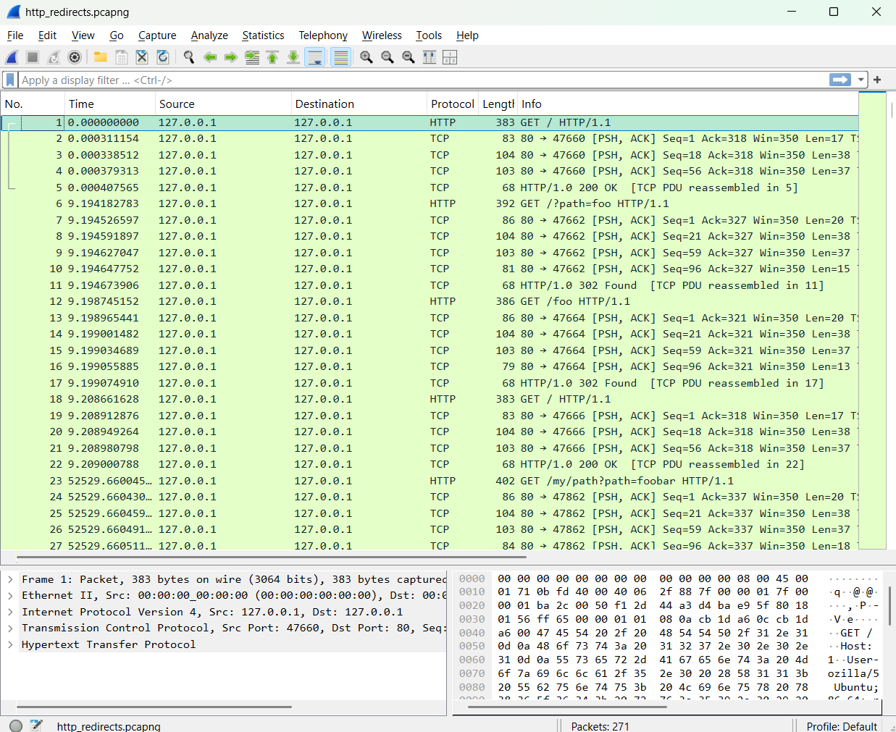

Query packet
- Packet number: 1
- Timestamp: Not provided
- Source IP: 192.168.170.8
- Source port: 32795
- Destination IP: 192.168.170.20
- Destination port: 53
- Query name: google.com
- Query type: TXT
- Transaction ID: 0x1032
3. Response packet
- Packet number: 2
- Timestamp: Not provided
- Transaction ID matches: Unable to verify from the displayed details alone; the listed transaction IDs are both 0x1032, suggesting a match.
- Response code: Not provided in the displayed details
- Answer record: Response observed; the actual DNS answer records are not provided.
4. Interpretation
The client at 192.168.170.8 sent a DNS query to the DNS server at 192.168.170.20 requesting the TXT records for google.com. The query was sent from UDP port 32795 to destination port 53.
A response packet was subsequently captured from the DNS server to the client. It has the same apparent transaction ID, 0x1032, and the reverse source and destination addresses and ports. This is consistent with a response to the original query. However, the DNS response code and TXT answer contents cannot be established from the supplied packet details.
5. Limitations
- The capture timestamps are not included in the supplied evidence.
- The packet capture establishes that a response was observed, but further inspection of the DNS response details is needed to confirm the returned records and response status.

- The actual TXT answer records are not shown, so the result of the lookup cannot be determined.
- The displayed information suggests a matching query and response, but the DNS transaction fields should be inspected directly to confirm the match.
6. Evidence references
- Query: dns.cap, packet 1
- Response: dns.cap, packet 2

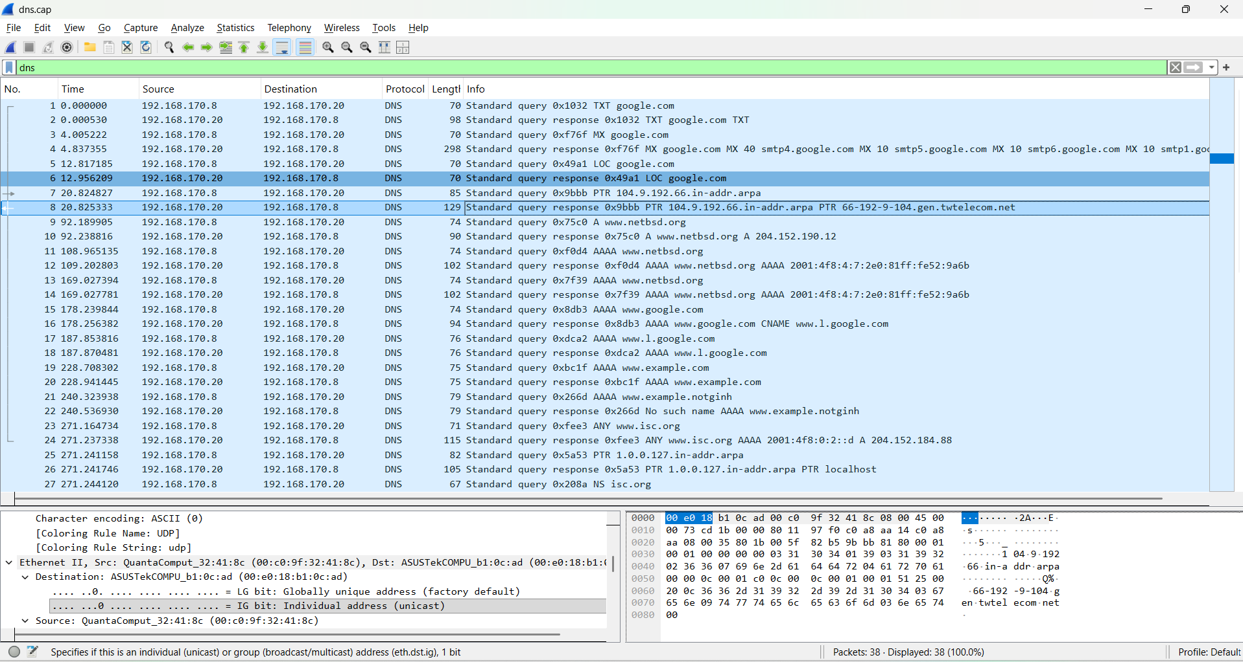
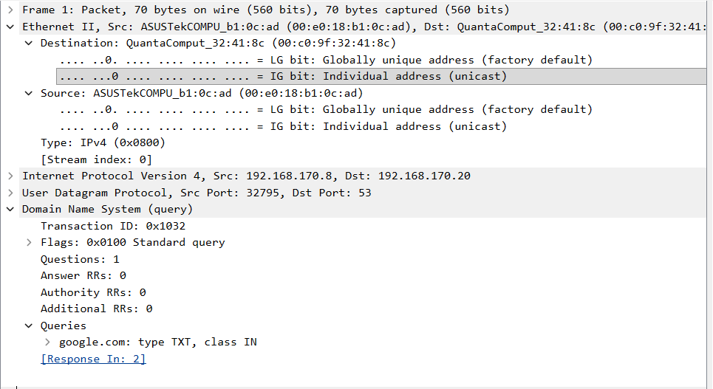

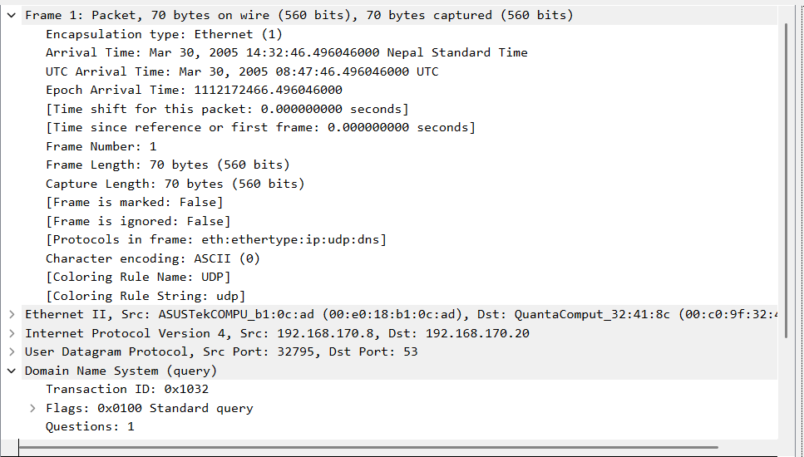

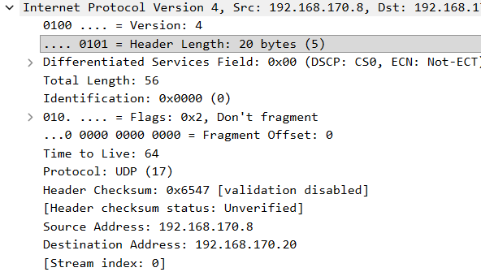

HTTP

HTTP Packet Analysis
1. File information
- Filename: http_redirects.pcapng
- Analysis date: October 26, 2026
- Filter used: http
2. Request evidence
- Packet number: 29
- Timestamp: March 28, 2018, 22:58:11.635937777 Nepal Standard Time
- Source IP and port: 127.0.0.1:47864
- Destination IP and port: 127.0.0.1:80
- Method: GET
- Host: 127.0.0.1
- URI/path: /my/foobar
- HTTP version: HTTP/1.1
- Full request URI: http://127.0.0.1/my/foobar
- 3. Response evidence
  - Packet number: Not provided in the supplied response details
  - Timestamp: March 28, 2018, 22:58:11 Nepal Standard Time (from the HTTP Date header; exact packet timestamp unavailable)
  - Status code: 302 Found
  - Response direction: Verified — server to client
  - Redirect observed: Yes
  - Location header: /
  - Server: SimpleHTTP/0.6 Python/2.7.14

4. Interpretation
The client sent an HTTP GET request to the local web server at 127.0.0.1, requesting the resource /my/foobar over TCP port 80. The request used HTTP/1.1.
The server responded with HTTP/1.0 302 Found, indicating a temporary redirect. The Location: / header instructs the client to navigate to the root path (/) instead of the originally requested /my/foobar resource.
The response identifies the server software as SimpleHTTP/0.6 Python/2.7.14. Since both endpoints use the loopback address 127.0.0.1, this communication occurred locally on the same machine.
The evidence confirms that a redirect was issued. However, the supplied response does not establish whether the browser subsequently followed the redirect or whether the request to / succeeded.

5. Limitations and privacy
  - The response packet number and exact packet timestamp were not provided with the response text.
  - The HTTP Date header gives the server-reported time, but it is not a substitute for the precise capture timestamp.
  - The subsequent request to / and its response have not been provided, so successful completion of the redirect cannot be confirmed.
  - No passwords, cookies, authentication tokens, or other obvious secrets appear in the supplied HTTP headers.

6. Evidence references
  - Request: http_redirects.pcapng, packet 29
  - Response: http_redirects.pcapng, packet number not yet identified
To complete the evidence references: In Wireshark, apply tcp.stream == 5 && http.response, locate the packet containing HTTP/1.0 302 Found, and record its packet number and capture timestamp.

